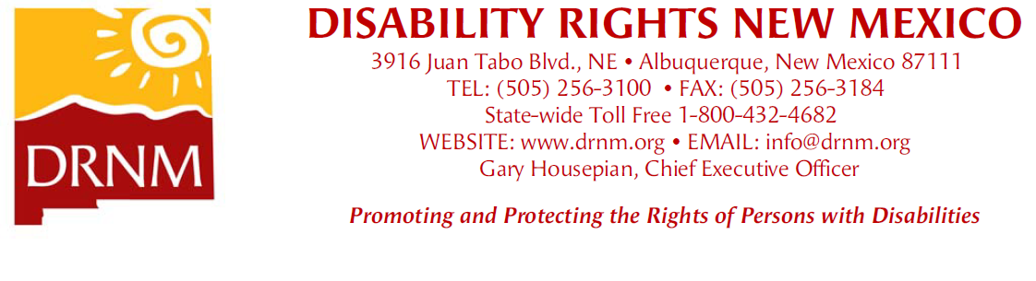

Approved by DRNM BOD 09/26/25

**Abuse / Neglect / Exploitation**

Decrease the abuse, neglect and exploitation of people with disabilities by improving the practices of programs and facilities in congregate settings for people with disabilities and/or where there are significant allegations of abuse, neglect or exploitation.

**A/N/E.1 [System]**Provide outreach and conduct trainings in facilities serving persons with mental illness or developmental disabilities, with an emphasis on psychiatric hospitals, boarding homes and other congregate care settings, to inform individuals of their rights and of DRNM’s availability to investigate and resolve problems.

**A/N/E.2 [Monitoring]**Conduct routine monitoring of facilities serving persons with disabilities for the purpose of identifying possible abuse or neglect, and compliance with service recipient rights and safety.

**A/N/E.3**Conduct investigations of alleged or suspected abuse or neglect where there appears to be a pattern or recurrence of significant abuse or neglect, where there has been a death or life-threatening injury, or where the alleged abuse or neglect is particularly egregious and produce reports/recommendations as appropriate.

**A/N/E.4**Pursue personal injury, wrongful death, or serious civil rights violation litigation where there is a clear opportunity to improve the practices of a provider or public service agency, private co-counsel is available, and fees may be available.

**A/N/E.5**Identify, develop, and pursue as appropriate advocacy strategies to address abuse, neglect, or other discriminatory practices by the criminal justice system, including law enforcement.

**Access & Rights**

Reduce or eliminate barriers or discriminatory practices faced by people with disabilities.

**AR.1**Advocate on behalf of individuals or groups where there is discrimination in a public accommodation under the NM Human Rights Act.

**AR.2**Provide assistance to individuals with disabilities denied access to public places, including public accommodations, based on their use of a service animal (as defined under state law and the ADA).

**AR.3**Assist people with disabilities to have access to shelter and opportunities to rent or own homes and apartments in their communities, including advocacy for housing, as well as temporary housing, to be accessible to people with disabilities to the extent required by law.

**Assistive Technology**

Expand the provision and use of assistive technology necessary for people with disabilities.

**AT.1**Assist people with disabilities to contest a denial of requested evaluation for assistive technology, to obtain necessary assistive technology devices and services, repair assistive technology devices, and/or to receive the training and support needed to utilize the devices, through coverage from their health insurance, public schools, or other available sources.

**Brain Injury**

Promote the expansion and implementation of services needed by individuals with brain injuries.

**BI.1**Assist eligible individuals or applicants with traumatic brain injuries who have been denied or terminated from appropriate services, who face inappropriate modification/reduction in such services, or who face other barriers to accessing such services.

**Community-Based Services**

Increase the number of individuals with disabilities who receive appropriate, high-quality community-based services that enable them to live productively and independently in community settings.

**C.1**Assist individuals in need of long term or other community-based services, including those who choose to self-direct services, who have been denied access to such services, or for whom the level of services offered or provided is inadequate.

**C.2 [System]** Continue to pursue the *M.G. v. Armijo* litigation to expand access to private-duty nursing services for medically fragile children specifically, and more broadly to medically necessary Medicaid services for participants generally.

**Employment and Vocational Rehabilitation**

Advance the employment opportunities for people with disabilities by holding state vocational rehabilitation programs accountable, by promoting competitive and integrated employment opportunities, and by reducing the barriers to retain, obtain, or return to work for persons with disabilities.

**EM.1**Advocate that eligible applicants or recipients are informed of and receive an appropriate range of individualized services from state vocational rehabilitation and independent living programs, and monitor the use of Order of Selection and its impact on eligible applicants.

**EM.2**Receive complaints from Social Security beneficiaries who have experienced a denial, delay, or other barrier in an effort to secure, retain, or return to work, and provide direct advocacy as appropriate.

**EM.3**Receive complaints from individuals not Social Security beneficiaries who have experienced a denial, delay, or other barrier in an effort to secure, retain, or return to work, and provide direct advocacy as appropriate.

**Help America Vote Act**

Improve accessibility for voters with disabilities to increase voter turnout by promoting and advocating for voter accessibility, providing outreach and trainings to both election officials and voters with disabilities, and working with state and county officials to ensure accessibility.

**HAVA.1**Promote participation in and equal access to elections by providing direct advocacy for clients, voter registration services, surveying polling places for accessibility, providing information and assistance on voting rights, and providing outreach and training on the rights of voters with disabilities, with a particular emphasis on voter education and registration for transition students who will be 18 years of age prior to the next election.

**HAVA.2 [System]**Provide training on voting accessibility and best practices for working with individuals with disabilities, to state and county election officials as well as poll workers, and collaborate with state and county election officials and poll workers to help ensure voter accessibility, including access to web sites, necessary to access voter registration and absentee ballots.

**Mental Health Services**

Expand the rights of individuals to receive appropriate mental health services, both in residential and outpatient mental health facilities and programs.

**MH.1**Assist and advocate for individuals in need of mental health services in cases where services are delayed, denied, or significantly reduced, or where the amount, duration, or scope of services offered is clearly inadequate, and where there is serious risk to the individual’s health or safety, or a serious risk of hospitalization or placement in a residential treatment facility, or when there appears to be a violation of an individual’s rights in a residential treatment facility, including a detention facility.

**MH.2 [System]**Advocate for the rights of people in need of mental health services to receive the services they request timely and in community-based settings whenever possible.

**MH.3 [System]**Pursue state oversight of boarding homes.

**MH.4 [System]**Within the *Kevin S.* case, advocate for the rights of children with disabilities in state custody to appropriate, individualized, accessible, adequate, and coordinated medical, mental health, and behavioral health services in safe and stable placements that are the least restrictive and appropriate to their needs from the Children, Youth and Families Department and the Health Care Authority.

**Public Policy**

Expand, support and utilize the capacity of DRNM as well as individuals and organizations in the disability community to influence public policies and systemic changes in policies, statutes and regulations affecting individuals with disabilities.

**P.1 [System]**Review and comment on proposed regulatory changes in Medicaid and other public programs that have a significant effect on eligibility, benefits, services, or procedural protections for persons with disabilities.

**P.2 [System]**Participate in the Disability Coalition to support collaborative public policy advocacy across multiple disability organizations.

**P.3 [System]**Educate legislators and other policy makers about issues that impact the rights of people with disabilities.

**Self-Determination**

Advance the rights of people with disabilities to have control over the decisions that affect their lives.

**SD.1**Advocate for the prevention, termination, or limiting to the least restrictive alternative of substitute decision-making arrangements such as guardianship, treatment guardianship, or representative payee appointments; promote supported decision-making approaches whenever possible, and when substitute decision-making is necessary, promote the most responsive arrangements available.

**SD.2 [Monitoring]**Promote or provide oversight of Representative Payees for Social Security beneficiaries when the Payee is in a potential conflict situation, monitor the conditions of beneficiaries and address other Payee issues, with respect to Payees monitored by DRNM pursuant to requests from the Social Security Administration or as otherwise identified by DRNM.

**Special Education**

Advocate for the delivery of a Free Appropriate Public Education (FAPE) for every student in New Mexico who qualifies for Special Education services or is entitled to a 504 Plan.

**ED.1**Advocate for students with Individualized Education Plans (IEPs) or Section 504 Plans that are inadequate or whose substantial lack of implementation by their local school districts prevents the student from benefiting from education.

**ED.2** Advocate for students who may be eligible for special education services or 504 Plans but have been denied evaluations or when a requested evaluation has been unreasonably delayed.

**ED.3** Advocate for students at Manifestation Determination Reviews (MDRs) and/or at disciplinary hearings such as Long-Term Suspension/Expulsion hearings.

**ED.4**Advocate against the use of restraint, seclusion, or law enforcement involvement, and for the use of positive behavior interventions and supports.

**ED.5 [System]** In connection with the *Yazzie/Martinez vs. New Mexico* consolidated cases and related policy efforts, advocate for a greater number and higher quality of special education resources in New Mexico public schools, toward improved educational outcomes for students with disabilities, including readiness for college or a career.